**Name: Fabian LeFevre**

**Date: 9/25/2018**

**CSI3660 Lab 2 Report**

1) What is the IP address of your virtual machine?

**141.210.25.90 /24**

2) Paste your ‘Network and Host Name' window screenshot here.

<paste here>

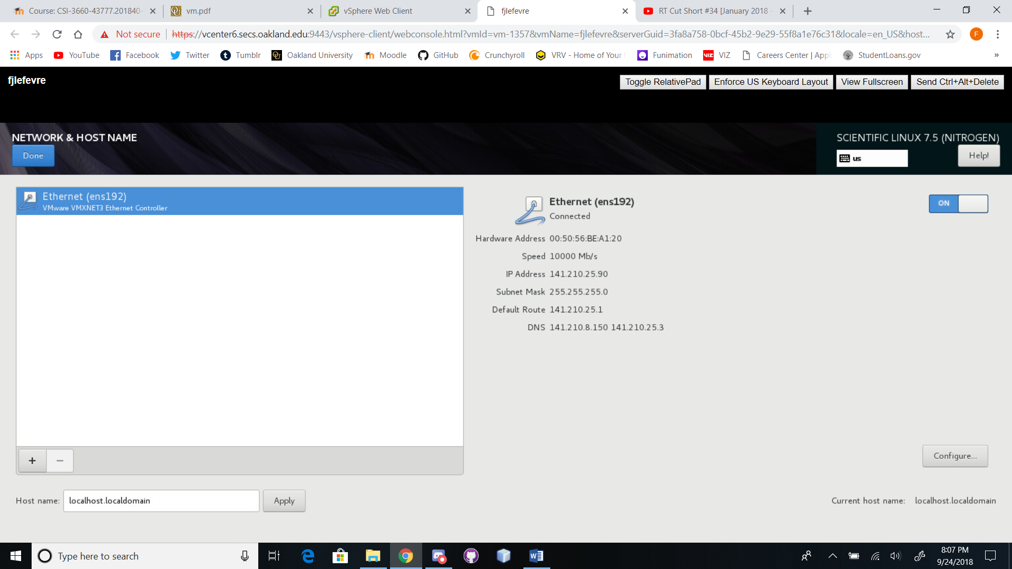

3)  What is the purpose of:

a) The home directory?

**GIve the user a place to work and store files/directories that is unique to them**

b) The user and group ID’s?

**The purpose of the user is to have a personal profile or set of settings for use when the user is working within a given system. The group ID’s purpose is to give each user a set of restrictions and access.**

4)  In general, describe the task that you just accomplished.  What was the overall purpose? Moreover, why do we need to install a *filesystem* on a blank hard drive?

**We installed and configured Linux on a virtual machine for the purposes of our class. The purpose of this is to get us acquainted with the multiple interfaces we will use in order to interact with the virtual machine. The reason we need a filesystem is to have a hierarchy in which folders and files are organized and stored, which there are multiple kinds that are used for a specific purpose.**

5) What is the difference between archiving and compressing files? Include an example of this difference.

**Archiving is the catalog and storage of items, in this case, directories and files copied and stored (mirrored or image of) to a single file.**

**EX: Zipping or creating a .tar file like we did in this lab.**

**Compressing is taking a file or set of files and archiving them in a way that takes up less space or memory, like creating a file that holds multiple specific files’ information but in a way that better utilizes space.**

**EX: Creating a compressed zipped file.**

6) Describe the process for creating a user who should have administrative privileges, including the commands necessary, and what the ‘wheel’ group is intended for.

**Access the terminal**

**Login**

**Use sudo privileges to run the following**

**sudo adduser fredericks**

**sudo adduser palagudi**

**sudo usermod -aG wheel fredericks**

**sudo usermod -aG wheel palagudi**

**groups fredericks**

**groups palagudi**

**The intention of the wheel group is to keep track of users with admin permissions.**

7) Provide a short description of (be sure to cite your source):

  a. What SFTP is

  b. How to use SFTP to transfer files

**SFTP is the protocol that provides FTP, file transfer service, over a SSH connection. (SOURCE: CompTIA Network+ N10-006, Keith Barker and Kevin Wallace ISBN-13 978-0-7897-5408-0 pg. 53)**

**Use SFTP to transfer files by setting up a SSH connection that utilizes SSH keys for encryption. Then utilize the “get filename” or “get -r directoryname” commands. (SOURCE: https://www.digitalocean.com/community/tutorials/how-to-use-sftp-to-securely-transfer-files-with-a-remote-server)**

**OR, you can connect to the terminal with MobaXterm with a session connecting with SSH or SFTP, select the file/directory in the file hierarchy on the left with right-click and finally select download.**

8) Demonstrate that both the **fredericks** and **palagudi** users are in the wheel group.

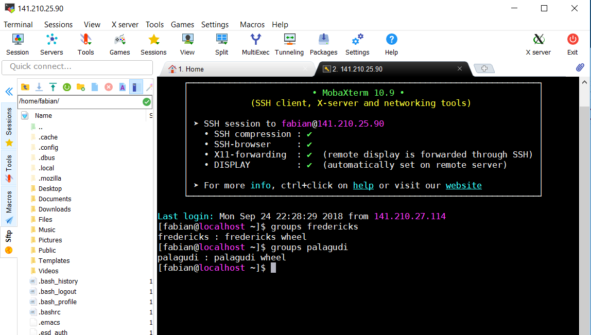

9) Provide a short conclusion that summarizes the task and details any problems that you encountered throughout the lab.  If you had no problems, mention that as well.

**Our task is to configure a Virtual Linux Machine. To do so we needed to install the proper version of Linux, Scientific Linux. Create our own base user account for the machine. Change the settings of the machine to run a terminal/text-based interface rather than a graphical desktop interface. Establish profiles for other users who would use our terminal machine. Finally, open up ports and enable protocols for data/file transmission.**

**My issues were setting up MobaXterm’s connection and getting to the remote desktop/virtual machine through Vcenter (Flash, SECS information and navigation issues)**

10) Demonstrate that you are able to download files, using SFTP, from your server (screenshot from Step 15).

